Module 3
Selenium Python Automation using Behave BDD Framework
Wipro Python Automation Training Project
1. Introduction
The project is a web automation framework developed in Python using Selenium and Behave Behavior Driven Development (BDD) framework. The work was organized as a series of practical automation tasks to write readable test cases, execute browser-based tests, test-data-driven automation, and improve maintainability with the Page Object Model (POM). Test scenarios were written in Gherkin in a clear Given-When-Then format. Python step definitions tied scenarios to Selenium browser actions.
2. Objectives
- Set up and execute a Python automation framework using Behave and Selenium.
- Create readable BDD test scenarios using Gherkin syntax.
- Automate end-to-end web application flows in a simulated local environment.
- Demonstrate test-data-driven automation using multiple input datasets.
- Apply the Selenium Page Object Model to separate page elements and actions from test logic.
- Organize the project so that individual assignments can be executed and maintained independently.
3. Technologies and Tools Used
The programming language used in the project is Python, Selenium WebDriver for browser automation, Behave for BDD execution, Gherkin for scenario definition. The development environment was Visual Studio Code and a Python virtual environment was used to isolate the project dependencies. Version control and project management was done with Git and GitHub. The simulation web application was a small local HTML login application used for demonstration of the automation flows.
4. Implementation
The project was carried out through three assignments. Assignment 1 set up the Selenium and Behave automation framework. Feature files had readable test scenarios while Python step definitions handled browser actions like opening the login page typing in user details clicking the login button and checking what showed on the screen. The project also included environment setup. Teardown so that browser resources could be properly released after tests ran.
Assignment 2 brought in test-data-driven automation. A Behave Scenario Outline was used to run the login process with different data sets. The examples included an username and password as well as an incorrect combination. A CSV file was added to store the test data. This method cuts down on repetition because the same automation steps work for test cases, without rewriting code.
Assignment 3 built on the framework by using the Selenium Page Object Model. Selenium locators and actions tied to pages were moved into a separate LoginPage class. Step definitions stayed focused on describing what the test should do while the Page Object took care of interacting with the web page. This split made the code easier to read and maintain. It also made it simpler to update page elements later since changes only needed to happen in one place.
5. Project Structure
The end Git repo was organized as a collection of individual automation assignments. Each assignment has its own feature files, step definitions, test application or support files and requirements as appropriate. The assignment 3 also has the pages directory for the Page Object Model. A root .gitignore file was used to prevent committing virtual environments, Python cache files and IDE-specific files to the repository.
6. Testing and Results
The implemented scenarios show successful and unsuccessful login flows. The same Scenario Outline is used to run the data driven tests with different input values and the expected result is verified. The Page Object Model version does the same functional validation while keeping all Selenium locators and page actions in one place. The project was also committed to Git and pushed to GitHub, which provided a versioned copy of the complete automation work.
features/login.feature
Feature: Login functionality
Scenario: Successful login
Given I open the login page
When I enter a valid username
And I enter a valid password
And I click the login button
Then I should see the successful login message
Scenario: Invalid login
Given I open the login page
When I enter an invalid username
And I enter an invalid password
And I click the login button
Then I should see the login error message
features/steps/login_steps.py
from pathlib import Path
from behave import given, when, then
from selenium import webdriver
from selenium.webdriver.common.by import By
def login_page_url():
page = Path(__file__).resolve().parents[2] / "test_app" / "login.html"
return page.as_uri()
@given("I open the login page")
def step_open_login_page(context):
context.driver = webdriver.Chrome()
context.driver.maximize_window()
context.driver.get(login_page_url())
@when("I enter a valid username")
def step_enter_valid_username(context):
context.driver.find_element(By.ID, "username").send_keys("student")
@when("I enter a valid password")
def step_enter_valid_password(context):
context.driver.find_element(By.ID, "password").send_keys("robot123")
@when("I enter an invalid username")
def step_enter_invalid_username(context):
context.driver.find_element(By.ID, "username").send_keys("wrong_user")
@when("I enter an invalid password")
def step_enter_invalid_password(context):
context.driver.find_element(By.ID, "password").send_keys("wrong_password")
@when("I click the login button")
def step_click_login(context):
context.driver.find_element(By.ID, "login-button").click()
@then("I should see the successful login message")
def step_verify_success(context):
message = context.driver.find_element(By.ID, "message")
assert message.text == "Login successful"
@then("I should see the login error message")
def step_verify_error(context):
message = context.driver.find_element(By.ID, "message")
assert message.text == "Invalid username or password"
Figure 1: Behave test-run output for Assignment 1 (Selenium + Behave login automation). It shows the "Invalid login" scenario executing step by step (open login page, enter invalid credentials, click login, see the error message), followed by the run summary confirming 1 feature, 2 scenarios and all 10 steps passed.
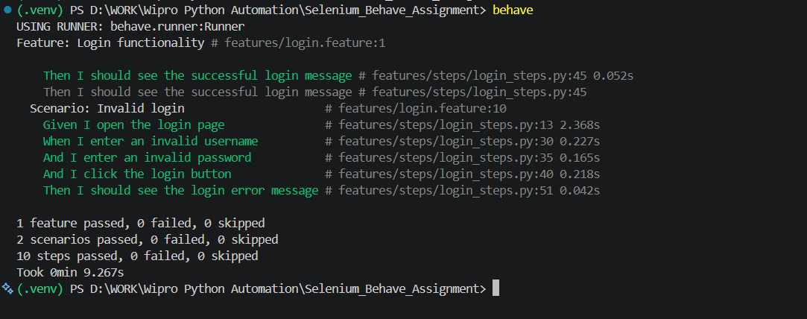
features/login_data.feature
Feature: Data Driven Login Automation
Scenario Outline: Login using different test data
Given I open the login page
When I enter username "<username>"
And I enter password "<password>"
And I click the login button
Then I should get "<expected>" result
Examples:
| username | password | expected |
| student | robot123 | success |
| wrong_user | wrong_password | error |
features/steps/login_data_steps.py
from pathlib import Path
from behave import given, when, then
from selenium import webdriver
from selenium.webdriver.common.by import By
@given("I open the login page")
def step_open_login_page(context):
context.driver = webdriver.Chrome()
context.driver.maximize_window()
page = Path(__file__).resolve().parents[2] / "test_app" / "login.html"
context.driver.get(page.as_uri())
@when('I enter username "{username}"')
def step_enter_username(context, username):
context.driver.find_element(By.ID, "username").send_keys(username)
@when('I enter password "{password}"')
def step_enter_password(context, password):
context.driver.find_element(By.ID, "password").send_keys(password)
@when("I click the login button")
def step_click_login(context):
context.driver.find_element(By.ID, "login-button").click()
@then('I should get "{expected}" result')
def step_verify_result(context, expected):
message = context.driver.find_element(By.ID, "message").text
if expected == "success":
assert message == "Login successful"
elif expected == "error":
assert message == "Invalid username or password"
else:
raise AssertionError(f"Unknown expected result: {expected}")
Figure 2: Behave test-run output for Assignment 2 (data-driven login automation). It shows the Scenario Outline running the login steps against multiple data sets, returning both "success" and "error" results, with the summary confirming 1 feature, 2 scenarios and all 10 steps passed.
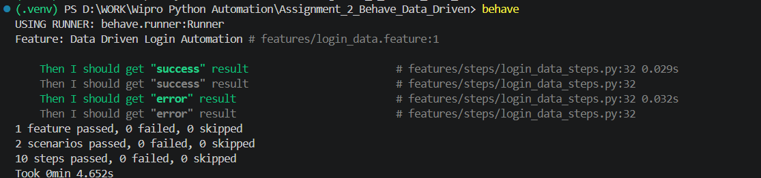
features/login.feature
Feature: Data driven login using Page Object Model
Scenario Outline: Login with different test data
Given I am on the login page
When I enter username "<username>"
And I enter password "<password>"
And I click the login button
Then the login result should be "<expected>"
Examples:
| username | password | expected |
| student | robot123 | success |
| wrong_user | wrong_password | error |
features/steps/login_steps.py
from pathlib import Path
from behave import given, when, then
from selenium import webdriver
from pages.login_page import LoginPage
@given("I am on the login page")
def step_open_login_page(context):
context.driver = webdriver.Chrome()
context.driver.maximize_window()
page = Path(__file__).resolve().parents[2] / "test_app" / "login.html"
context.driver.get(page.as_uri())
context.login_page = LoginPage(context.driver)
@when('I enter username "{username}"')
def step_enter_username(context, username):
context.login_page.enter_username(username)
@when('I enter password "{password}"')
def step_enter_password(context, password):
context.login_page.enter_password(password)
@when("I click the login button")
def step_click_login(context):
context.login_page.click_login()
@then('the login result should be "{expected}"')
def step_verify_login_result(context, expected):
actual_message = context.login_page.get_message()
if expected == "success":
assert actual_message == "Login successful"
elif expected == "error":
assert actual_message == "Invalid username or password"
else:
raise AssertionError(f"Unknown expected result: {expected}")
pages/login_page.py
from selenium.webdriver.common.by import By
class LoginPage:
"""Page Object for the demo login page."""
USERNAME = (By.ID, "username")
PASSWORD = (By.ID, "password")
LOGIN_BUTTON = (By.ID, "login-button")
MESSAGE = (By.ID, "message")
def __init__(self, driver):
self.driver = driver
def enter_username(self, username):
self.driver.find_element(*self.USERNAME).clear()
self.driver.find_element(*self.USERNAME).send_keys(username)
def enter_password(self, password):
self.driver.find_element(*self.PASSWORD).clear()
self.driver.find_element(*self.PASSWORD).send_keys(password)
def click_login(self):
self.driver.find_element(*self.LOGIN_BUTTON).click()
def get_message(self):
return self.driver.find_element(*self.MESSAGE).text
Figure 3: Behave test-run output for Assignment 3 (Page Object Model login automation). It shows the same data-driven scenarios re-run through the LoginPage Page Object class, again producing "success" and "error" results correctly, with all scenarios and steps passing.
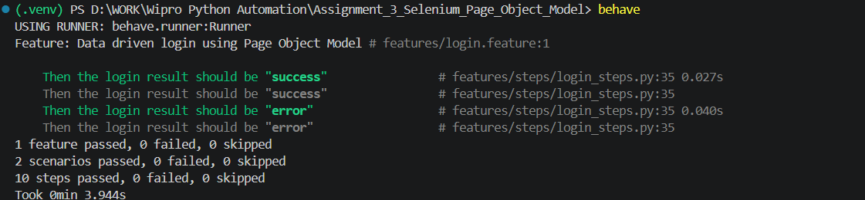
7. Conclusion
The project gave hands-on experience in creating a Python web automation framework that uses Behave and Selenium. The journey from BDD automation to data-driven execution and then, to the Page Object Model shows how an automation suite can be arranged for reuse and maintainability. The finished repository offers a base that can grow with more pages, more scenarios, more datasets, more assertions, more waits, more reporting and more intricate end-to-end workflows.

